### **FinOps in Action: Standardizing AWS Resources with Tag Policies**

Managing resources in AWS can quickly become complex as your organization grows. Without clear governance, you risk inconsistent tagging, higher costs, and difficulty in tracking ownership or compliance.

From a **FinOps (Cloud Financial Management)** perspective, tagging is one of the most critical practices. Tags allow finance, engineering, and operations teams to collaborate around cloud spend by providing visibility into **who owns what** and **how costs should be allocated**.

But not all tags serve the same purpose. We can divide them into two categories:

* **Mandatory tags** → Required for governance, compliance, and cost allocation (e.g., ownerid, costcenter, environment).
* **Discretionary tags** → Useful but optional, often added by teams for their own workflows (e.g., project, squad, application).

While discretionary tags give teams flexibility, **mandatory tags are non-negotiable** for enabling FinOps practices like chargeback, showback, and cost anomaly detection.

That’s where **AWS Tag Policies** (part of AWS Organizations) come in. They allow you to **define and enforce standardized tags** across all accounts — ensuring consistency, accountability, and better cost visibility.

In this article, we’ll walk through how to use tag policies effectively, with practical examples and screenshots.

**Why Do Tags Matter?**

Tags in AWS are **key-value pairs** you can assign to resources. They help you:

* Track costs (e.g., costcenter:1234)
* Manage environments (e.g., environment:prod)
* Enforce compliance and security (e.g., dataclassification:confidential)
* Improve automation and reporting

But when teams create resources without consistent tagging, reporting and automation break down. This is where **tag policies** help enforce compliance.

### **Enabling Tag Policies in AWS Organizations**

First, make sure your AWS Organization has **Tag Policies enabled**.

In the **Policies** section of AWS Organizations, you’ll find multiple governance tools (backup policies, service control policies, etc.). Enable **Tag Policies**:

### **Creating a Tag Policy**

Let’s create a **mandatory tag policy** to ensure all resources include key metadata.

1. Go to **Organizations** **→ Policies → Tag Policies → Create new tag policy**.

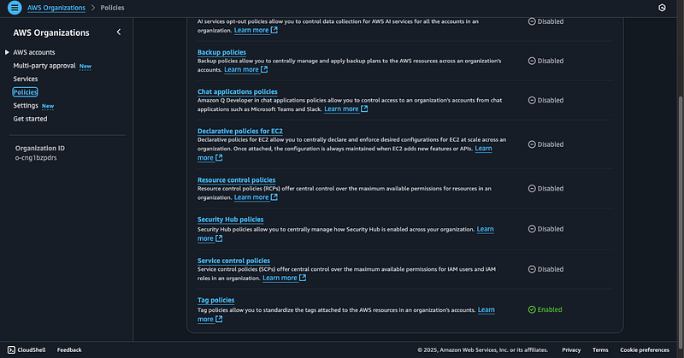Figure 1: Policy selection

1. Give it a name, like mandatory tags.
2. Add a description to explain its purpose (e.g., *“make sure to add an owner”*).
3. Define mandatory tag keys such as:

* ownerid
* region
* costcenter
* environment
* dataclassification

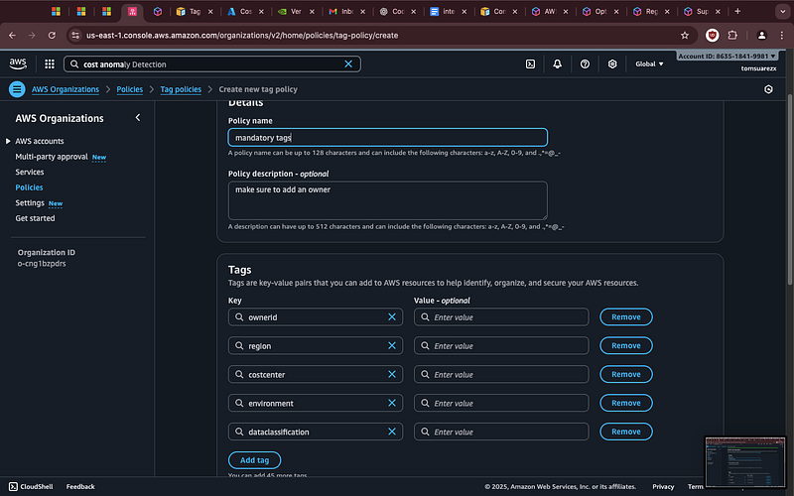Figure 2: Key Value pairs for tags

This ensures every resource includes the required metadata.

### **Defining Allowed Values**

Sometimes you want to **control the values** that a tag can take. For example, the environment tag should only allow dev or prod.

Using tag policies, you can enforce this easily:

Now, any attempt to use Env=Development or environment=production will be flagged as non-compliant.

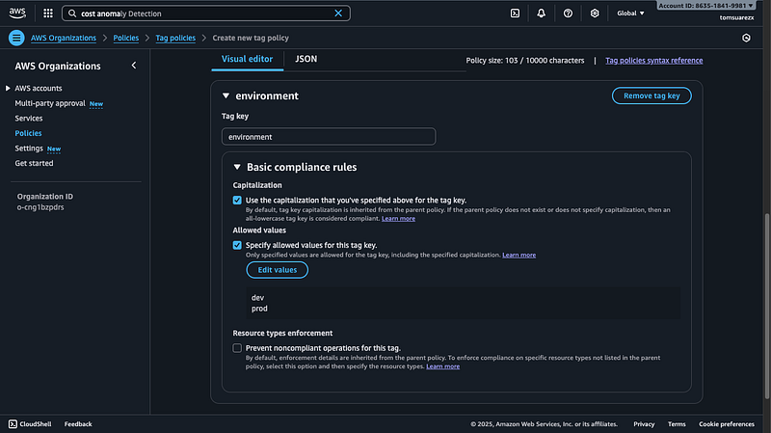Figure 3: Allowed values for environment tag

### **Enforcing Compliance**

****Figure 4: Preventing non compliant resources

By default, tag policies only check compliance. To **prevent non-compliant operations**, you can enforce them on specific AWS services.

For example, applying enforcement to **API Gateway resources**:

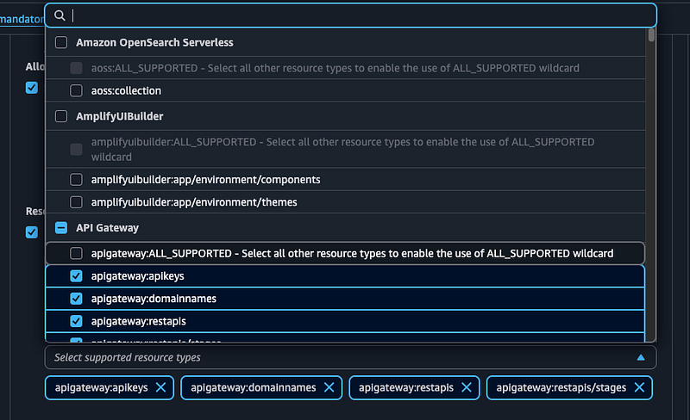Figure 5: preventing api gw creation if it does not have the right key value pairs for the tags

And then enabling the option to block noncompliant operations:

This ensures that resources cannot be created without the required tags.

### **Benefits of AWS Tag Policies**

* ✅ **Consistent Tagging** across all accounts and resources
* ✅ **Improved Cost Tracking** with mandatory costcenter or ownerid tags
* ✅ **Automation & Security** with environment and data classification tags
* ✅ **Compliance Enforcement** by preventing creation of untagged resources

### **Final Thoughts**

AWS Tag Policies are a powerful governance tool for organizations looking to scale responsibly. By defining clear rules for tags — and enforcing them — you reduce chaos, improve reporting, and make your AWS environment more secure and cost-efficient.

If your teams are struggling with inconsistent tagging, implementing **tag policies in AWS Organizations** is one of the best first steps toward governance at scale.